Document

Criterion B: Design
1. Program Design 2
1-1. Webpage Structure Chart 2
1-2. Homepage 2
1-2. Adding New Particle 3
1-3. Adjusting environment variables 4
2. User Decision Flowchart 5
3. Program Overview Flowchart 7
4. Code Design Overview Flowchart 8
5. Algorithm Flowchart 8
5-1. “update()” function 8
5-2. Updating the position of an individual particle 10
5-2-1. Velocity Verlet 10
5-2-2. “updatePosition()” function 11
5-3. “BorisPush()” function 11
7. Test Plan 13
8. Resources 15

1. Program Design

1-1. Webpage Structure Chart
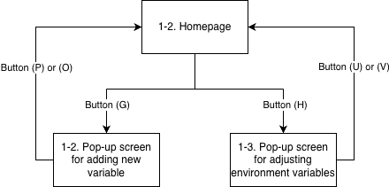

1-2. Homepage

Physics Simulation
(D)
(F)
(E)
(H)
(G)
(B)
(A)
(C)

Alphabet name of the feature | Feature explanation
(A) | Displays environmental variables, such as gravitational and magnetic field strength, dt, and drag coefficient
(B) | Selection button of the particle to display
(C) | Display of variables of the particle, such as velocity, mass, and charge
(D) | “Stop” button that pauses the simulation
(E) | “Resume” button that resumes paused simulation
(F) | “Reset” button that deletes all variables
(G) | “Add New Particle” button
(H) | “Adjust Values” button that enables manipulation of environmental variables as listed in (A)

1-2. Adding New Particle

Physics Simulation
(D)

Particle Characteristics
(I)
(D)
(F)
(E)
(H)
(G)
(B)
(A)
(C)
(J)
(K)
(L)
(M)
(N)
(P)
(O)
The pop-up screen shown above will appear when the user clicks the button (G).

Alphabet name of the text box | Input box of what
I | Initial position
J | Initial velocity
K | Initial acceleration
L | Mass
M | Charge
N | Display radius

The user can cancel their decision by pressing the (O) button, or complete adding a particle by pressing the (P) button.

1-3. Adjusting environment variables

Physics Simulation
(D)

Particle Characteristics
(Q)
(D)
(F)
(E)
(H)
(G)
(B)
(A)
(C)
(R)
(S)
(T)
(V)
(U)
The pop-up screen shown above will appear when the user clicks the button (H).
Alphabet name of the text box | Input box of what
Q | Gravitational field strength
R | dt; time step
S | B; Uniform magnetic field strength
T | Drag coefficient

The user can cancel their decision by pressing the (U) button, or complete adding a particle by pressing the (V) button.

2. User Decision Flowchart
The flowchart below shows how the user will interact with the program.
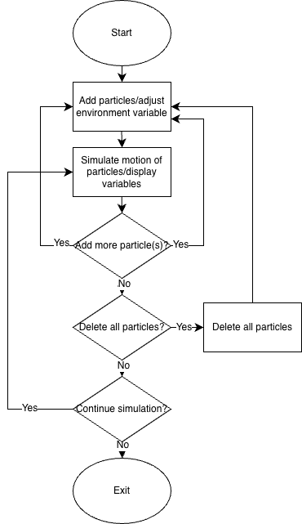

3. Program Overview Flowchart
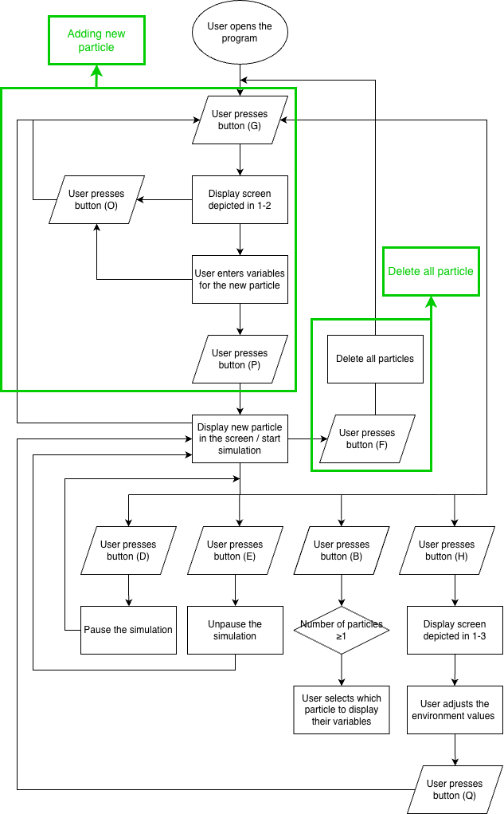

4. Code Design Overview Flowchart
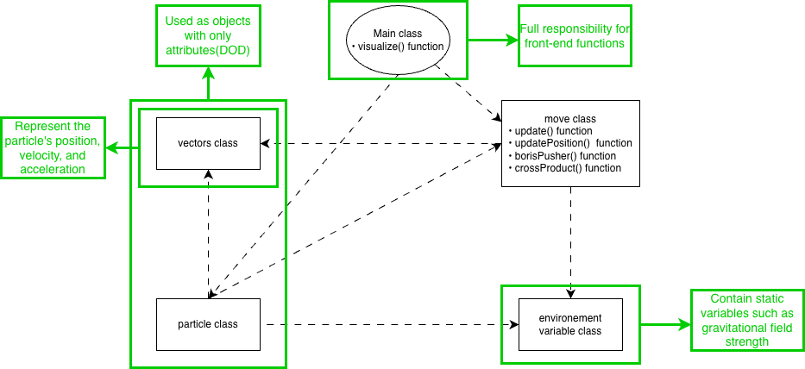

5. Algorithm Flowchart

5-1. “update()” function
This function updates all positions in the particle list.
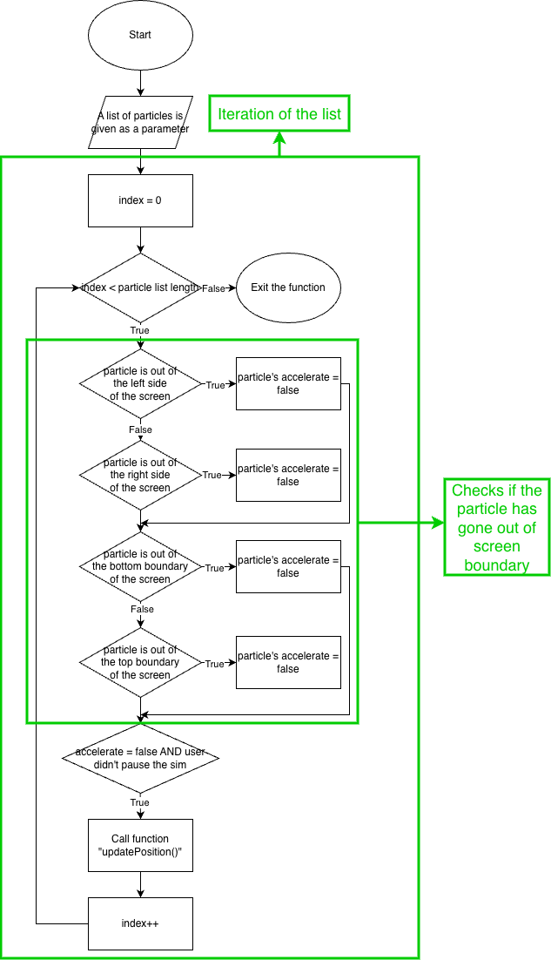

5-2. Updating the position of an individual particle

5-2-1. Velocity Verlet
I referred this resource: Verlet Integration · Arcane Algorithm Archive
Velocity Verlet is a modified version of the Verlet integrator algorithm. It consists of four equations:
- $v\left(t+\frac{Δt}{2}\right)=v(t)+\frac{1}{2}a(t)Δt$
- $x\left(t+Δt\right)=x(t)+v\left(t+\frac{Δt}{2}\right)Δt$
- Derive $a\left(t+Δt\right)$ in the position $x\left(t+Δt\right)$.
- $v\left(t+Δt\right)=v\left(t+\frac{Δt}{2}\right)+\frac{1}{2}a\left(t+Δt\right)Δt$
Below flowchart illustrates Velocity Verlet algorithm:
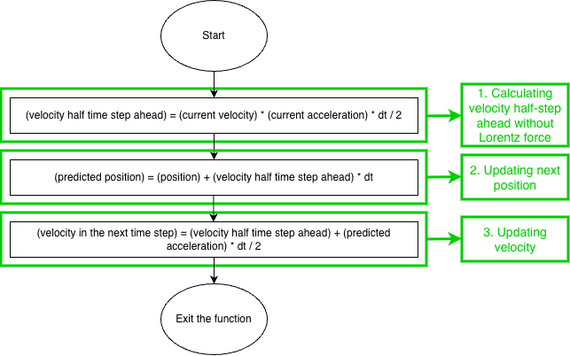

5-2-2. “updatePosition()” function
Below is the flowchart of the “updatePosition()” function. It will use the Verlet Integrator. Another function that uses the Boris pusher algorithm adjusts the velocity to account for the Lorentz force.
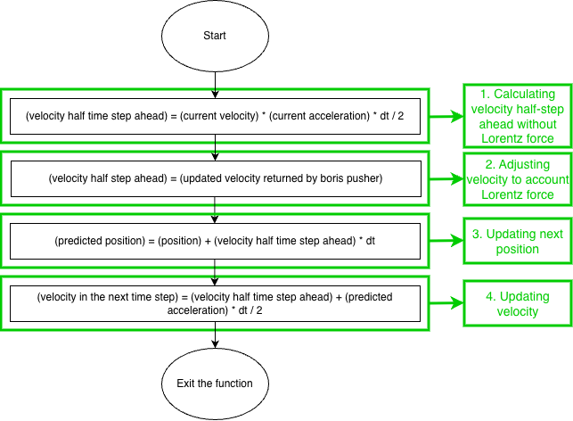

5-3. “BorisPush()” function
This function will use the Boris Pusher algorithm, which specializes in calculating the Lorentz force.
Below is the table of variables used in the flowchart, and a flowchart of the Boris pusher function. Since the Boris Pusher algorithm is complex, I initially coded it in a separate project file and compared my results with those from the source code in this GitHub repository.
Variable Symbol | Meaning
q | particle’s charge
m | particle’s mass
E | electrical field strength
B | magnetic field strength
dt | time step

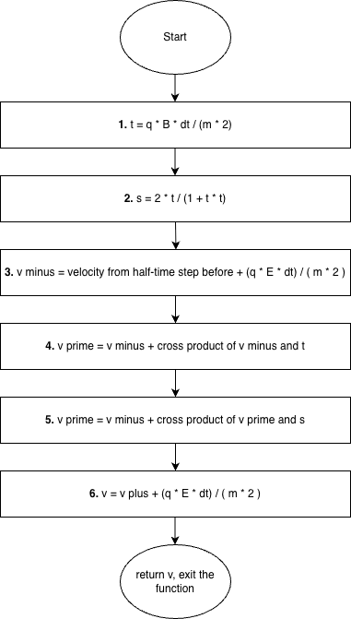

7. Test Plan
No. | SC | Feature | Input/Action | Expected Result
1 | 1 | Display particle | Starting the program | A green-filled circle with a radius of 10 pixels is displayed on the coordinate (30, 30)
2 | 1 | Particle accelerates in a predictable amount | Starting the program | A green circle falls down at a speed of 9.8 pixels per second
3 | 1 | Motion of particles follows correct physics logic: Boris Pusher is implemented correctly as part of the update function | 1. Implementing Boris Pusher using Dart in another project  2. Copying the correct version of Boris Pusher  3. Give the same particle parameters to both versions of Boris Pusher  4. Make two versions of the output adjusted velocity for 100 time steps of $\frac{1}{60}$. | Textual outputs of both versions of Boris Pusher should be the same
4 | 1 | Boundary condition | Starting the program | Partie’s motion and changes in acceleration and velocity stop upon reaching the screen boundary.
5 | 3 | Displays on the left side of the screen that show the particle’s position, velocity, acceleration, charge, mass, and display radius. | Temporarily exclude Boris Pusher and Verlet Integrator, letting the particle free-fall.  Starting the program | Textual displays appear on the left side of the screen.  Horizontal position, velocity, and acceleration stay unchanged  Acceleration stays 9.8.  Velocity increases.
6 | 5 | Displays on the left side of the screen that show environment variables | Starting the program | Shows default G strength, dt. uniform B, and drag coefficient, with all in proper labels
7 | 2 | Pop-up screen where the user can input preset values | Press the button (G) | A pop-up screen with the “Add new Particle” title and 6 text fields appears
8 | 2 | Data validation of inputs | Input 5 test cases:  1. Nothing  2. Alphabets  3. Symbols other than a comma  4. Nothing, followed by a comma and a decimal value  5. Decimal value and a comma, followed by nothing | 1. The program does not crash.  2. Inputs are done properly, as will be shown on the displays
9 | 1&2 | All particles are updated | Adding a second particle while the previously added particle is still in motion | Both particles move
10 | 6 | Pop-up screen where the user can adjust environment variable values | Pressing the button (H) after its addition to all text fields incorporated | Once the inputs are submitted, the values on the display reflect the change
11 | 4 | Stop button | Pressing button (D) | 1. Particles’ motions stop  2. Displaying values of the particles stops changing
12 | 4 | Resume button | Pressing button (E) | 1. Particles’ motions resume  2. Displaying values of the particles starts changing again from where they stopped
13 | 7 | Reset button | Pressing button (F) | Clear all particles
14 | 7 | Reset Button | Prevent displaying particle variables when there is no particle left in the list  Pressing button (F) | Clear all particles

8. Resources
- https://github.com/iwhoppock/boris-algorithm/blob/master/boris.py
- Verlet Integration · Arcane Algorithm Archive
- Particle Push in Magnetic Field (Boris Method)

Word Count: 261

